ODHS Timer interrupt multi LED toggle (no two led is on at the same time)

STM32F407VGT6 is used

*/* RCC clock LSE is connected*

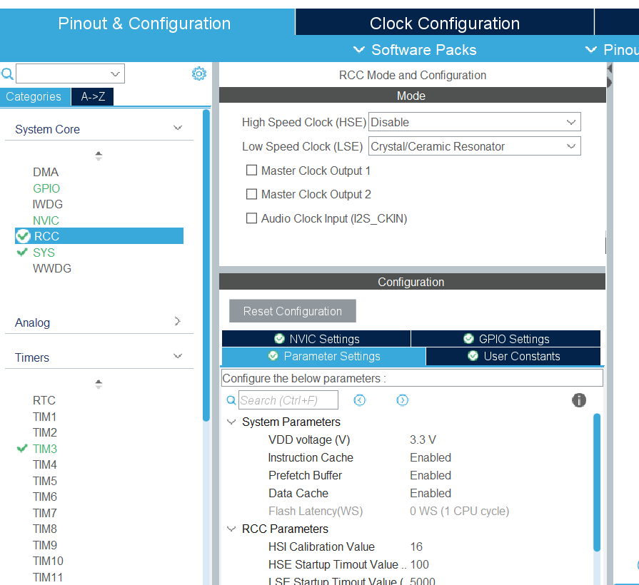

*Cant use LSI as not connected to the APB of the timers (APB1) */*

THUS HSI is used

Timer TIM3 configured as follows for Tout=1sec

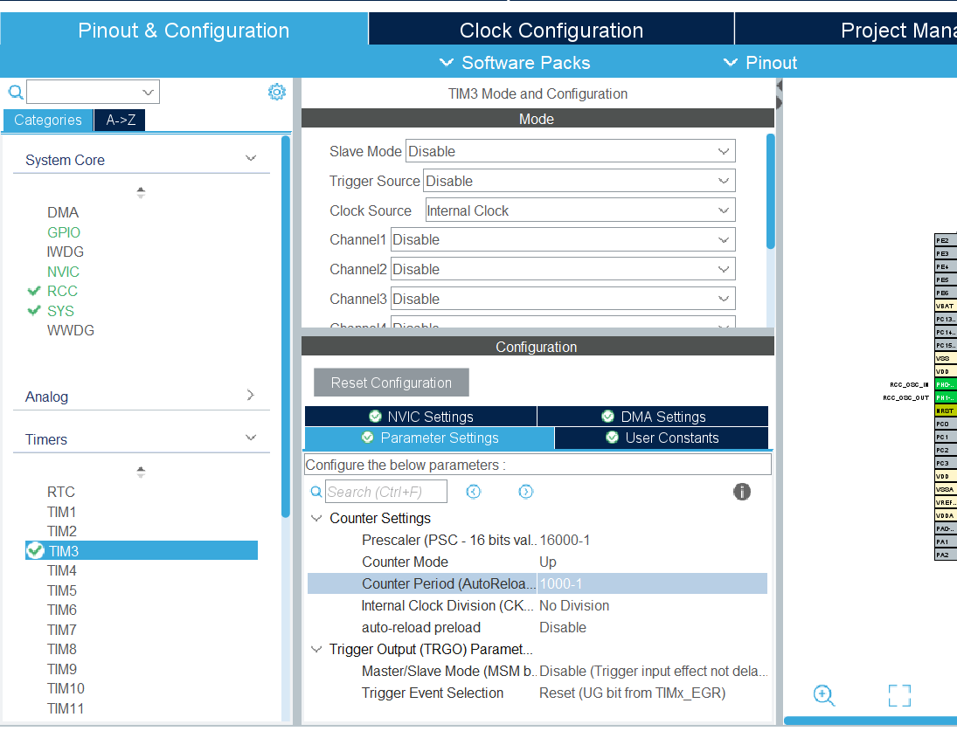

NVIC interrupt turned on

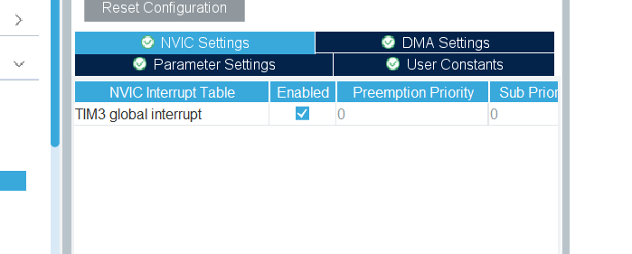

GPIOD PD12,13,14,15 set to output as connected to LED onboard

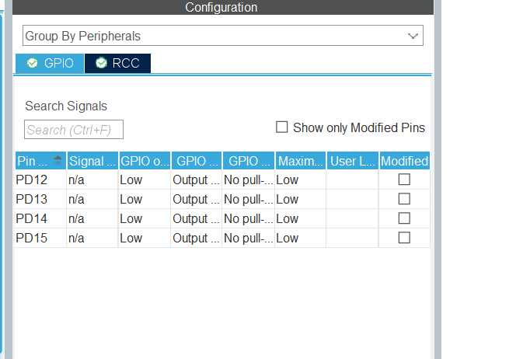

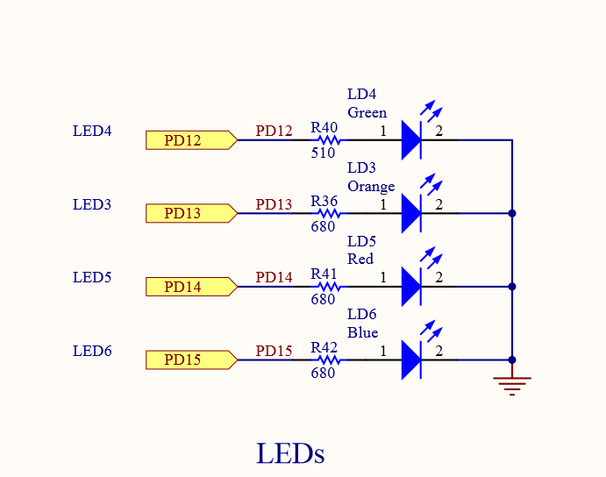

Code is generated and the inrrupt is modified in stm32fxx_it.c file as follows

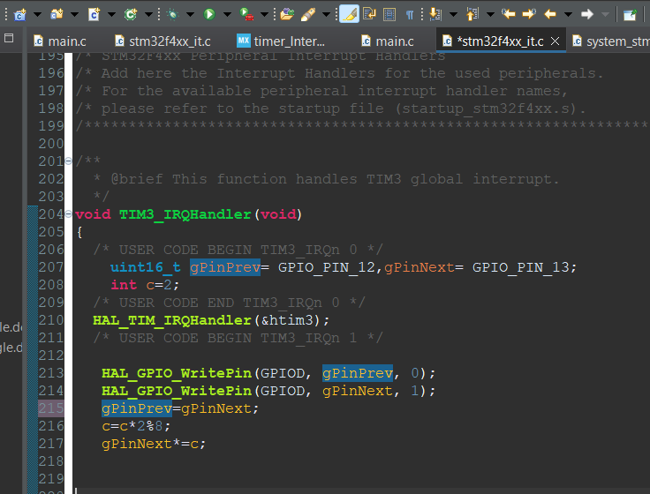

Need to check code. Did not work

REDOING

Pin config

